Lab Manual
Practical and Skills Development

CERTIFICATE

THE ASSIGNMENT ENTERED IN THIS REPORT HAVE BEEN SATISFACTORILY PERFORMED BY

Registration No |  | : 25BAI11315
Name of Student |  | : Sanskruti .R. Kanoje
Course Name |  | : Introduction to Problem Solving and Programming
Course Code |  | : CSE1021
School Name |  | : SCAI
Slot |  | : B11+B12+B13
Class ID |  | : BL2025260100796
Semester |  | : FALL 2025/26
Course Faculty Name |  | : Dr. Hemraj S. Lamkuche

Signature:
S.No  1  2  3  4  5  6  7  8 | Title of Practical  Write a function factorial(n) that calculates the factorial of a non-negative integer n (n!).  Write a function is_palindrome(n) that checks if a number  reads the same forwards and backwards.  Write a function mean_of_digits(n) that returns the average of all digits in a number.  Write a function digital_root(n) that repeatedly sums the  digits of a number until a single digit is obtained.  Write a function is_abundant(n) that returns True if the  sum of proper divisors of n is greater than n.  Write a function is_deficient(n) that returns True if the  sum of proper divisors of n is less than n.  Write a function for harshad number is_harshad(n) that  checks if a number is divisible by the sum of its digits.  Write a function is_automorphic(n) that checks if a  number's square ends with the number itself. | Date of Submission | Signature of Faculty

9  10  11  12  13  14  15  16 | Write a function is_pronic(n) that checks if a number is  the product of two consecutive integers.  Write a function prime_factors(n) that returns the list of prime factors of a number.  Write a function count_distinct_prime_factors(n) that returns  how many unique prime factors a number has.  Write a function is_prime_power(n) that checks if a number  can be expressed as pk where p is prime and k ≥ 1.  Write a function is_mersenne_prime(p) that checks if  2p - 1  is a prime number (given that p is prime).  Write a function twin_primes(limit) that generates all twin prime pairs up to a given limit.  Write a function Number of Divisors  (d(n)) count_divisors(n) that returns how many positive divisors a number has.  Write a function aliquot_sum(n) that returns the sum of all  proper divisors of n (divisors less than n).

17  18  19  20  21  22 | Write a function are_amicable(a, b) that checks if two  numbers are amicable (sum of proper divisors of a equals b and vice versa).  Write a function multiplicative_persistence(n) that counts  how many steps until a number's digits multiply to a single digit.  Write a function is_highly_composite(n) that checks if a  number has more divisors than any smaller number.  Write a function for Modular  Exponentiation mod_exp(base, exponent, modulus) that  efficiently calculates (baseexponent) % modulus.  Write a function Modular  Multiplicative  Inverse mod_inverse(a, m) that finds the number x such that (a * x) ≡ 1 mod m.  Write a function chinese Remainder Theorem  Solver crt(remainders, moduli) that solves a system of congruences x ≡ ri mod mi.

23  24  25  26  27  28  29 | Write a function Quadratic Residue  Check is_quadratic_residue(a, p) that checks if x2 ≡ a mod p has a solution.  Write a function order_mod(a, n) that finds the smallest  positive integer k such that ak ≡ 1 mod n.  Write a function Fibonacci Prime  Check is_fibonacci_prime(n) that checks if a number is both Fibonacci and prime.  Write a function Lucas Numbers  Generator lucas_sequence(n) that generates the first n  Lucas numbers (similar to Fibonacci but starts with 2,  1).  Write a function for Perfect Powers  Check is_perfect_power(n) that checks if a number can be  expressed as ab where a > 0 and b >  1.  Write a function Collatz Sequence  Length collatz_length(n) that returns the number of steps  for n to reach 1 in the Collatz conjecture.  Write a function Polygonal Numbers polygonal_number(s,

30  31  32  33  34 | n) that returns the n-th s-gonal number.  Write a function Carmichael Number  Check is_carmichael(n) that checks if a composite number  n satisfies an−1 ≡ 1 mod n for all a coprime to n.  Implement the probabilistic Miller-Rabin  test is_prime_miller_rabin(n, k) with k rounds.  Implement pollard_rho(n) for integer factorization using  Pollard's rho algorithm.  Write a function zeta_approx(s, terms) that approximates  the Riemann zeta function ζ(s) using the first 'terms' of the series.  Write a function Partition Function  p(n) partition_function(n) that calculates the number of  distinct ways to write n as a sum of positive integers.

Assignment
Date: 19-11-2025

TITLE: Run functions in Python without using external Library

AIM/OBJECTIVE(s): 1.Write a function factorial(n) that calculates the factorial of a non-negative integer n (n!).
- Write a function is_palindrome(n) that checks if a number reads the same forwards and backwards.
- Write a function mean_of_digits(n) that returns the average of all digits in a number.
- Write a function digital_root(n) that repeatedly sums the digits of a number until a single digit is obtained.
- Write a function is_abundant(n) that returns True if the sum of proper divisors of n is greater than n.
- Write a function is_deficient(n) that returns True if the sum of proper divisors of n is less than n.
- Write a function for harshad number is_harshad(n) that checks if a number is divisible by the sum of its digits. 8. Write a function is_automorphic(n) that checks if a number's square ends with the number itself.
- Write a function is_pronic(n) that checks if a number is the product of two consecutive integers.
- Write a function prime_factors(n) that returns the list of prime factors of a number.
- Write a function count_distinct_prime_factors(n) that returns how many unique prime factors a number has.
- Write a function is_prime_power(n) that checks if a number can be expressed as pk where p is prime and k ≥ 1.
- Write a function is_mersenne_prime(p) that checks if 2p - 1 is a prime number (given that p is prime).
- Write a function twin_primes(limit) that generates all twin prime pairs up to a given limit.
- Write a function Number of Divisors
(d(n)) count_divisors(n) that returns how many positive divisors a number has.
- Write a function aliquot_sum(n) that returns the sum of all proper divisors of n (divisors less than n).
- Write a function are_amicable(a, b) that checks if two numbers are amicable (sum of proper divisors of a equals b and vice versa).
- Write a function multiplicative_persistence(n) that counts how many steps until a number's digits multiply to a single digit.
- Write a function is_highly_composite(n) that checks if a number has more divisors than any smaller number.
- Write a function for Modular
Exponentiation mod_exp(base, exponent, modulus) that efficiently calculates (baseexponent) % modulus.

- Write a function Modular Multiplicative
Inverse mod_inverse(a, m) that finds the number x such that (a * x) ≡ 1 mod m.
- Write a function chinese Remainder Theorem Solver crt(remainders, moduli) that solves a system of congruences x ≡ ri mod mi.
- Write a function Quadratic Residue
Check is_quadratic_residue(a, p) that checks if x2 ≡ a mod p has a solution.
- Write a function order_mod(a, n) that finds the smallest positive integer k such that ak ≡ 1 mod n.
- Write a function Fibonacci Prime
Check is_fibonacci_prime(n) that checks if a number is both Fibonacci and prime.
- Write a function Lucas Numbers
Generator lucas_sequence(n) that generates the first n Lucas numbers (similar to Fibonacci but starts with 2,
1).
- Write a function for Perfect Powers
Check is_perfect_power(n) that checks if a number can be expressed as ab where a > 0 and b > 1.
- Write a function Collatz Sequence
Length collatz_length(n) that returns the number of steps for n to reach 1 in the Collatz conjecture.
- Write a function Polygonal Numbers polygonal_number(s,
n) that returns the n-th s-gonal number.
30. Write a function Carmichael Number
Check is_carmichael(n) that checks if a composite number n satisfies an−1 ≡ 1 mod n for all a coprime to n. 31. Implement the probabilistic Miller-Rabin test is_prime_miller_rabin(n, k) with k rounds.
- Implement pollard_rho(n) for integer factorization using Pollard's rho algorithm.
- Write a function zeta_approx(s, terms) that approximates the Riemann zeta function ζ(s) using the first 'terms' of the series.
- Write a function Partition Function p(n) partition_function(n) that calculates the number of distinct ways to write n as a sum of positive integers.

METHODOLOGY & TOOL USED:

1.
def factorial(n):
product = 1
for i in range(1,n+1):
product *= (i)
return product
print(factorial(10))

2.
def is_palindrome(n):
s = str(n) return s == s[::-1]
print(is_palindrome(121))
print(is_palindrome(123)) v = (1,2,3,4,5,6,7)
n = len(v)
i = sum(v)
print(i/n)

3.
v = (1,2,3,4,5,6,7)
def mean_of_digit(v):
n = len(v)
i = sum(v)
return(i/n) print(mean_of_digit(v))

4.
def digital_root(n): while n >= 10:
n = sum(int(digit) for digit in str(n))
return n
print(digital_root(1234))

5.
def is_abundant(n):
if n < 1:
return False
divisors_sum = 1
for i in range(2, int(n**0.5) + 1):
if n % i == 0:
divisors_sum += i
if i != n // i:
divisors_sum += n // i
return divisors_sum > n
print(is_abundant(12))

6.
def is_deficient(n):
if n <= 1:
return True
proper_divisor_sum = sum(i for i in range(1, n) if n % i == 0)
return proper_divisor_sum < n print(is_deficient(20))

7.
def is_harshad(n):
digit_sum = sum(int(d) for d in str(n))
return n % digit_sum == 0
print(is_harshad(15))
8.
def is_automorphic(n):
square = n * n
return str(square).endswith(str(n))
print(is_automorphic(5))

9.
def is_pronic(n):
if n < 0:
return False i = 0
while i * (i + 1) <= n:
if i * (i + 1) == n:
return True
i += 1
return False
print(is_pronic(22))

10.
def prime_factors(n):
factors = []
while n % 2 == 0:
factors.append(2)
n //= 2
i = 3
while i * i <= n:
while n % i == 0:
factors.append(i)
n //= i i += 2
if n > 2:
factors.append(n)
return factors
print(prime_factors(24))

11.
def count_distinct_prime_factors(n):
if n < 2:
raise ValueError
count = 0
temp = n
if temp % 2 == 0:
count += 1 while temp % 2 == 0:
temp //= 2
factor = 3
while factor * factor <= temp:
if temp % factor == 0:
count += 1
while temp % factor == 0:
temp //= factor
factor += 2
if temp > 1:
count += 1
return count print(count_distinct_prime_factors(2310))
12.
def is_prime_power(n):
if n < 2:
raise ValueError("Input must be a positive integer greater
than 1")
max_exponent = n.bit_length()
for k in range(1, max_exponent + 1):
root = round(n ** (1 / k))
for candidate in [root - 1, root, root + 1]:
if candidate < 2:
continue
power = candidate ** k
if power == n and is_prime(candidate):
return True
return False
def is_prime(num):
if num < 2:
return False
if num == 2:
return True
if num % 2 == 0:
return False
for i in range(3, int(num**0.5) + 1, 2):
if num % i == 0:
return False
return True
print(is_prime_power(27))
13.
def is_mersenne_prime(p):
if p < 2:
raise ValueError("Input p must be at least 2")
mersenne = 2**p - 1
known_mersenne_primes = {2, 3, 5, 7, 13, 17, 19, 31, 61, 89,
107, 127} if p in known_mersenne_primes:
return True
return is_prime_mersenne(mersenne)
def is_prime_mersenne(n):
if n < 2:
return False
if n == 2:
return True
if n % 2 == 0:
return False
limit = int(n**0.5) + 1
k = 1
divisor = 2 * k * (n.bit_length()) + 1
while divisor <= limit:
if n % divisor == 0:
return False
k += 1
divisor = 2 * k * (n.bit_length()) + 1
return True
print(is_mersenne_prime(7))
14.
def twin_primes(limit):
if limit < 3:
raise ValueError("Limit must be at least 3")
primes = sieve_of_eratosthenes(limit)
twin_pairs = []
for i in range(len(primes) - 1):
if primes[i + 1] - primes[i] == 2:
twin_pairs.append((primes[i], primes[i + 1]))
return twin_pairs
def sieve_of_eratosthenes(n):
if n < 2:
return []
sieve = [True] * (n + 1)
sieve[0] = sieve[1] = False
for i in range(2, int(n**0.5) + 1):
if sieve[i]:
sieve[i*i : n+1 : i] = [False] * len(sieve[i*i : n+1 :
i])
return [i for i, is_prime in enumerate(sieve) if is_prime]
print("Twin primes up to 20:")
print(twin_primes(20))

15.
def count_divisors(n):
if n <= 0:
raise ValueError("Input must be a positive integer")
if n == 1: return 1
count = 1
i = 2
while i * i <= n:
if n % i == 0:
if i * i == n:
count += 1
else:
count += 2
i += 1
return count + 1 print(f"d(12) = {count_divisors(12)}")

16.
if n <= 0:
return "enter a positive integer"
x = 0
for i in range(1, n // 2 + 1):
if n % i == 0:
x += i
return x
17.
def are_amicable(a,b):
if a<0:
return "enter a positive number"
x=0
for i in range (1,a//2+1):
if a % i ==0:
x+=i
if x==b:
return True

18.
def multiplicative_persistence(n):
if n <10:
return 0
persistence=0
number=n
while number>=10:
product=1
for i in str(number):
product *= int(i)
number= product
persistence += 1
return persistence

19.
import math
def count_divisors(num):
if num <= 0:
return 0
divisor_count = 0
for i in range(1, int(math.sqrt(num) + 1)):
if num % i == 0:
if num / i == i:
divisor_count += 1
else:
divisor_count += 2
return divisor_count
def is_highly_composite(n):
if n <= 0:
return False
original_divisor_count = count_divisors(n)
for i in range(1, n):
if count_divisors(i) >= original_divisor_count:
return False
return True

20.
def mod_exp(base, exponent, modulus):
if modulus == 1:
return 0
result = 1
base %= modulus
while exponent > 0:
if exponent % 2 == 1:
result = (result * base) % modulus
base = (base * base) % modulus
exponent //= 2
return result

21.
def mod_inverse(a, m):
a = a % m
m0 = m
x = 0
y = 1
if m == 1:
return 0
while a > 1:
q = m // a
m, a = a, m % a x, y = y - q * x, x
if a != 1:
raise ValueError("Modular inverse does not exist (a and m
are not coprime)")
if y < 0: y += m0
return y
# Single use case
A = 3
M = 11
X = mod_inverse(A, M)
print(f"The modular multiplicative inverse of {A} mod {M} is {X}")
print(f"Check: ({A} * {X}) mod {M} = {(A * X) % M}")
22.
def mod_inverse(a, m):
a = a % m
m0 = m
x = 0
y = 1
if m == 1:
return 0
while a > 1:
q = m // a
m, a = a, m % a x, y = y - q * x, x
if a != 1:
raise ValueError("Modular inverse does not exist (a and m
are not coprime)")
if y < 0:

y += m0
return y
def crt(remainders, moduli):
"""Solves a system of congruences using the Chinese Remainder
Theorem."""
if len(remainders) != len(moduli):
raise ValueError("Remainders and moduli lists must have the same length")
# N is the product of all moduli
N = 1
for m in moduli:
N *= m
result = 0
for r_i, m_i in zip(remainders, moduli):
# n_i is the product of all moduli except m_i
n_i = N // m_i
try:
x_i = mod_inverse(n_i, m_i)
except ValueError as e:
raise ValueError(f"Moduli are not pairwise coprime or
modular inverse failed for {n_i} mod {m_i}: {e}")
result += r_i * n_i * x_i
return result % N
R = [2, 3, 2]
M = [3, 5, 7]
X = crt(R, M)
print(f"System of congruences: x ≡ {R[0]} mod {M[0]}, x ≡ {R[1]} mod
{M[1]}, x ≡ {R[2]} mod {M[2]}") print(f"The unique solution modulo {M[0] * M[1] * M[2]} is x = {X}")
print(f"Check: {X} mod 3 = {X % 3}, {X} mod 5 = {X % 5}, {X} mod 7 =
{X % 7}")

23.
def is_prime(n):
if n <= 1:
return False
if n <= 3:
return True
if n % 2 == 0 or n % 3 == 0:
return False i = 5
while i * i <= n:
if n % i == 0 or n % (i + 2) == 0:
return False
i += 6
return True
def is_quadratic_residue(a, p):
a = a % p
if not is_prime(p):
raise ValueError("Modulus p must be a prime number.")
if a == 0:
return True
if p == 2:
return True
exponent = (p - 1) // 2
result = pow(a, exponent, p)
return result == 1
A_RESIDUE = 9
P_PRIME = 17
A_NON_RESIDUE = 3

print(f"Is {A_RESIDUE} a quadratic residue mod {P_PRIME}?
{is_quadratic_residue(A_RESIDUE, P_PRIME)}")
print(f"Is {A_NON_RESIDUE} a quadratic residue mod {P_PRIME}?
{is_quadratic_residue(A_NON_RESIDUE, P_PRIME)}")

24.
import math
def order_mod(a, n):
if n <= 1:
raise ValueError("Modulus n must be greater than 1.")
if math.gcd(a, n) != 1:
raise ValueError(f"The order is undefined because {a} and
{n} are not coprime (gcd(a, n) != 1).")
k = 1
current_power = a % n
while current_power != 1:
current_power = (current_power * a) % n
k += 1
return k
A = 3
N = 7
K = order_mod(A, N)
print(f"The order of {A} modulo {N} is k = {K}")
print(f"Check: {A}^{K} mod {N} = {pow(A, K, N)}")

25.
def is_prime_internal(n):
if n <= 1:
return False
if n <= 3:
return True
if n % 2 == 0 or n % 3 == 0:
return False i = 5
# Check for factors up to sqrt(n)
while i * i <= n:
if n % i == 0 or n % (i + 2) == 0:
return False
i += 6
return True
def is_fibonacci_number_internal(n):
if n < 0:
return False
def is_perfect_square(k):

if k < 0:
return False # Calculate the integer square root
s = int(k**0.5)
return s * s == k
# Check the two conditions for the Fibonacci property
# 5*n^2 + 4 or 5*n^2 - 4 must be a perfect square.
if is_perfect_square(5 * n * n + 4) or is_perfect_square(5 * n * n - 4):
return True
return False
def is_fibonacci_prime(n):
if not is_prime_internal(n):
return False
if not is_fibonacci_number_internal(n):
return False
return True
# Single use case
TEST_NUMBER_1 = 13
TEST_NUMBER_2 = 7
TEST_NUMBER_3 = 8
TEST_NUMBER_4 = 29
print(f"{TEST_NUMBER_1} is Fibonacci and prime?
{is_fibonacci_prime(TEST_NUMBER_1)}") print(f"{TEST_NUMBER_2} is Fibonacci and prime?
{is_fibonacci_prime(TEST_NUMBER_2)}")
print(f"{TEST_NUMBER_3} is Fibonacci and prime?
{is_fibonacci_prime(TEST_NUMBER_3)}")
print(f"{TEST_NUMBER_4} is Fibonacci and prime?
{is_fibonacci_prime(TEST_NUMBER_4)}")
26.
def lucas_sequence(n):
if n <= 0:
return
a, b = 2, 1
if n >= 1:
yield a
if n >= 2:
yield b
for _ in range(2, n):
c = a + b
yield c
a, b = b, c
n_terms = 10
lucas_gen = lucas_sequence(n_terms)
print(f"The first {n_terms} Lucas numbers are:")
print(list(lucas_gen))

27.
def is_perfect_power(n):
if n <= 0:
return False
if n == 1:
return True
max_a = int(n**0.5)
for a in range(2, max_a + 1):
if n % a == 0:
power = a * a while power <= n:
if power == n:
return True
power = power * a
return False
print(f"Is 8 a perfect power? {is_perfect_power(8)}")

28.
def collatz_length(n):
if n < 1:
return 0
steps = 0
while n != 1:
if n % 2 == 0:
n = n // 2
else:
n = 3 * n + 1
steps += 1
return steps
start_num = 6
print(f"The Collatz sequence length for {start_num} is: {collatz_length(start_num)}")

29.
def polygonal_number(s, n):
if s < 3 or n < 1:
return None
numerator = (s - 2) * (n ** 2) - (s - 4) * n
return numerator // 2
print(f"The 5th 3-gonal (triangular) number is: {polygonal_number(3,
5)}")

30.
def _is_prime(n):
if n < 2:
return False
if n == 2 or n == 3:
return True
if n % 2 == 0 or n % 3 == 0:
return False
i = 5
while i * i <= n:
if n % i == 0 or n % (i + 2) == 0:
return False
i += 6
return True

def _get_prime_factors(n):
factors = set()
if n % 2 == 0:
factors.add(2)
while n % 2 == 0:
n //= 2
i = 3
while i * i <= n:
if n % i == 0:
factors.add(i)
while n % i == 0:
n //= i
i += 2
if n > 2:
factors.add(n)
return factors
def is_carmichael(n):
if n < 2 or _is_prime(n):
return False
factors = _get_prime_factors(n)
product_of_factors = 1
for p in factors:
product_of_factors *= p
if product_of_factors != n:
return False
for p in factors:
if (n - 1) % (p - 1) != 0:
return False

31.
def is_prime_miller_rabin(n, k=20):
if n < 2:
return False
if n == 2 or n == 3:
return True
if n % 2 == 0:
return False

s = 0
d = n - 1
while d % 2 == 0:
d //= 2
s += 1
for _ in range(k):
a = random.randint(2, n - 2)
x = pow(a, d, n)
if x == 1 or x == n - 1:
continue
for _ in range(s - 1):
x = (x * x) % n
if x == 1:
return False
if x == n - 1:
break
else:
return False
return True

32.
import random
import math
def modular_pow(base, exponent,modulus):
result = 1
while (exponent > 0):
if (exponent & 1):
result = (result * base) % modulus
exponent = exponent >> 1

base = (base * base) % modulus
return result
def pollard_rho(n):
if (n == 1):
return n
if (n % 2 == 0):
return 2
x = (random.randint(0, 2) % (n - 2))
y = x
c = (random.randint(0, 1) % (n - 1))
d = 1
while (d == 1):
x = (modular_pow(x, 2, n) + c + n)%n
y = (modular_pow(y, 2, n) + c + n)%n
y = (modular_pow(y, 2, n) + c + n)%n
d = math.gcd(abs(x - y), n)
if (d == n):
return pollard_rho(n)
return d

33.
def zeta_approx(s, terms):
if terms <= 0: return 0.0
zetasum = 0.0
for n in range(1, terms + 1):
zetasum += 1.0 / (n ** s)
return zetasum

34.
def partitions(n):
p = [0] * (n + 1)
p[0] = 1
for i in range(1, n + 1):
k = 1
while ((k * (3 * k - 1)) / 2 <= i) : p[i] += ((1 if k % 2 else -1) *
p[i - (k * (3 * k - 1)) // 2])
if (k > 0):
k *= -1
else:
k = 1 - k

return p[n]

Results Achieved :

Outputs :
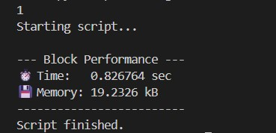
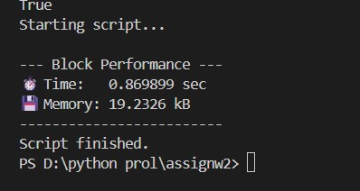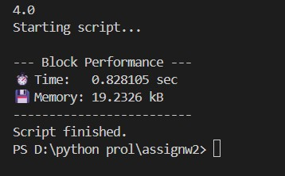

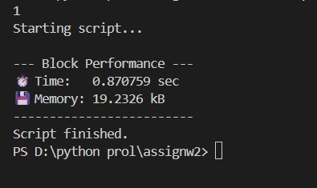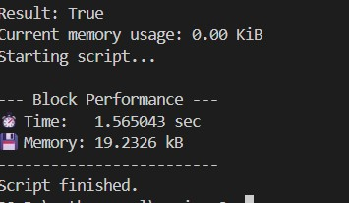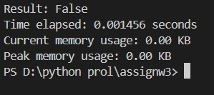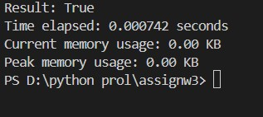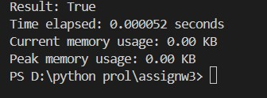
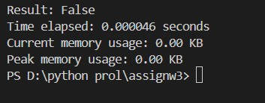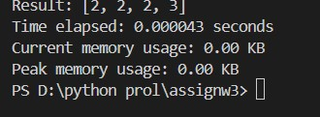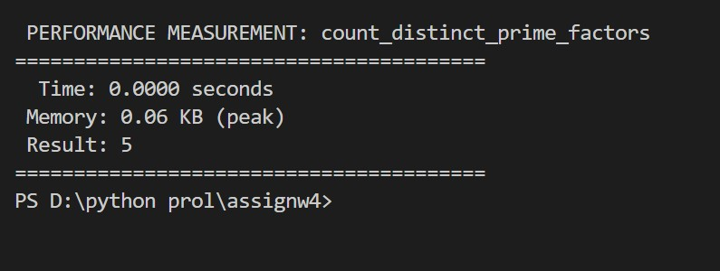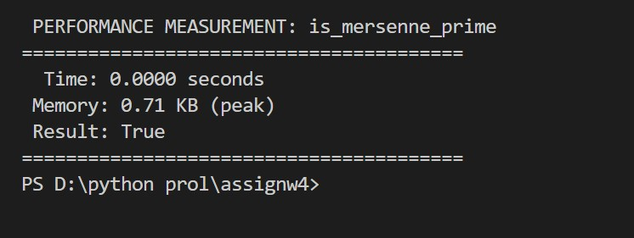
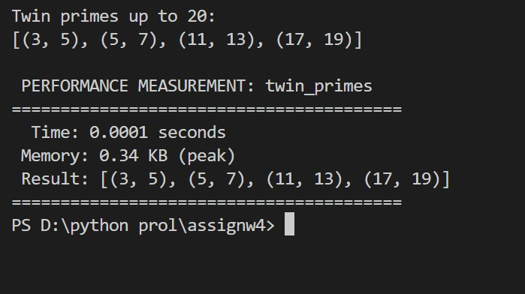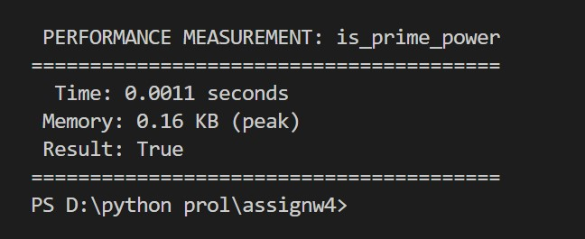
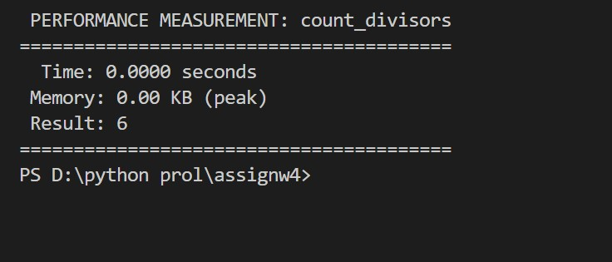
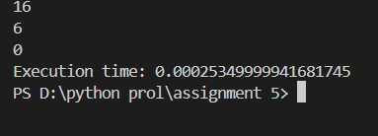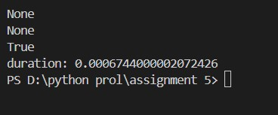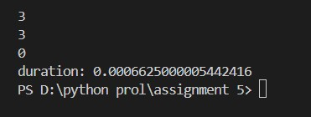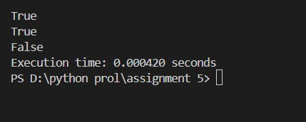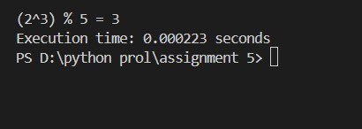
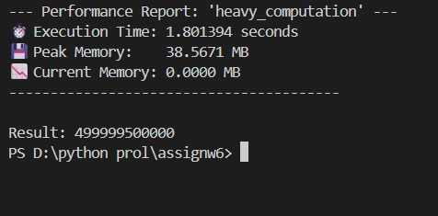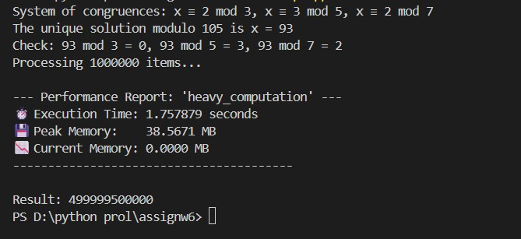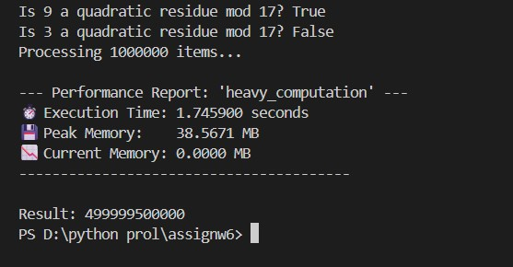
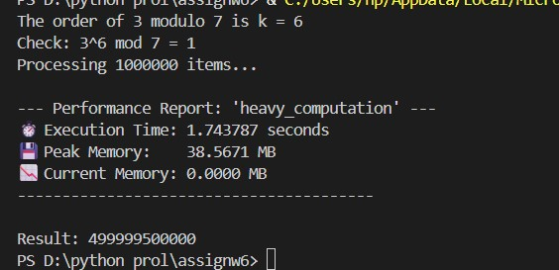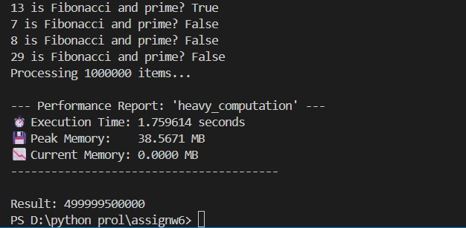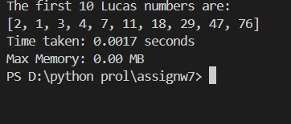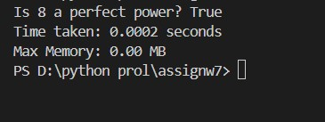
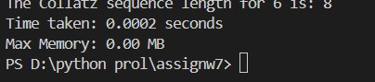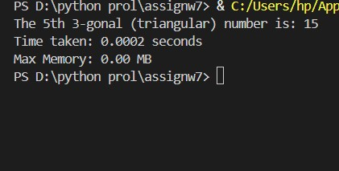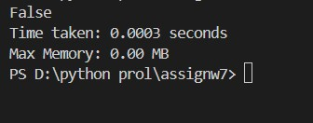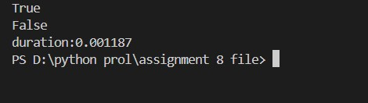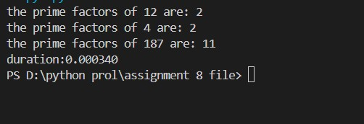
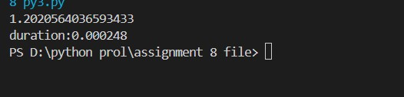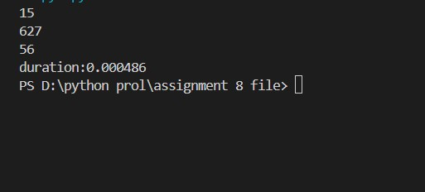

BRIEF DESCRIPTION:
factorial(n): Calculates the product of all integers from 1 to n. Used frequently in permutations and combinations.
is_palindrome(n): Checks if the number reads the same forwards and backwards (e.g., 121), usually by reversing the digits or converting to a string.
mean_of_digits(n): Extracts every digit from a number, sums them up, and divides by the count of digits to find the average value.
digital_root(n): A recursive process where you sum the digits of a number, then sum the digits of the result, repeating until only a single digit remains.
is_abundant(n): A number is "abundant" if the sum of its proper divisors (excluding the number itself) is greater than the number (e.g., 12).
is_deficient(n): The opposite of abundant; the sum of proper divisors is less than the number (e.g., 10).
is_harshad(n): Checks if the number is divisible by the sum of its own digits (e.g., 18 is divisible by 1+8=9).
is_automorphic(n): Checks if the square of the number ends with the number itself (e.g., $5^2 = 25$, $25^2 = 625$).
is_pronic(n): Checks if a number is the product of two consecutive integers, $n = x \times (x+1)$ (e.g., 12 is $3 \times 4$).
- prime_factors(n): Decomposes a number into its fundamental prime building blocks (e.g., 12 returns [2, 2, 3]).
- count_distinct_prime_factors(n): Similar to the above, but counts unique primes only (e.g., 12 has factors 2 and 3, so the count is 2).
- is_prime_power(n): Checks if a number consists of a single prime raised to a power $k$ (e.g., $8 = 2^3$, $27 = 3^3$).
- is_mersenne_prime(p): Checks if a number of the form $2^p - 1$ is prime. These are often the largest known prime numbers.
- twin_primes(limit): Finds pairs of prime numbers that are exactly 2 apart (e.g., 3 and 5, 11 and 13).
- count_divisors(n): Counts how many numbers divide $n$ evenly.
- aliquot_sum(n): Calculates the sum of all proper divisors of $n$. This is used to determine if a number is Perfect, Abundant, or Deficient.
- are_amicable(a, b): Checks for a friendly relationship where the aliquot sum of $a$ equals $b$, and the aliquot sum of $b$ equals $a$ (e.g., 220 and 284).
- multiplicative_persistence(n): Calculates how many times you must multiply the digits of a number together until you reach a single digit.
- is_highly_composite(n): Checks if a number has more divisors than any positive integer smaller than it. These are essentially "anti-primes." 20. mod_exp(base, exponent, modulus): Efficiently calculates $(base^{exponent}) \% modulus$. This is the core algorithm behind modern cryptography (RSA).
mod_inverse(a, m): Finds a number $x$ such that $a \cdot x \equiv 1 \pmod m$. This is essential for "decrypting" in cryptography.
crt(remainders, moduli) (Chinese Remainder Theorem): Solves a system of equations to find a number that leaves specific remainders when divided by specific divisors.
is_quadratic_residue(a, p): Determines if a number $a$ is a perfect square modulo $p$. Important in cryptography and determining solvability of equations.
order_mod(a, n): Finds the smallest power $k$ such that $a^k \equiv 1 \pmod n$. This relates to the cycles of numbers.
is_fibonacci_prime(n): Checks if a number exists in the Fibonacci sequence AND is also a prime number.
lucas_sequence(n): Generates numbers similar to Fibonacci ($L_n = L_{n-1} + L_{n-2}$) but starting with 2 and 1 instead of 0 and 1.
is_perfect_power(n): Checks if a number can be written as integer $a$ raised to integer power $b$ (where $b > 1$).
collatz_length(n): Simulates the "3n + 1" problem and counts how many steps it takes for a number to collapse down to 1.
polygonal_number(s, n): Calculates numbers that can be arranged in shapes (triangles, squares, pentagons) based on the formula for $s$-sided polygons.
- Detects "trick" numbers that are composite (not prime) but pass Fermat's basic primality test.
- A probabilistic test used by computers to check if huge numbers are prime very quickly with high accuracy.
- An integer factorization algorithm that is faster than simple trial division, used to break small to medium encryption keys.
- : Approximates the Riemann Zeta function, a complex infinite series with deep connections to the distribution of prime numbers.
- Calculates the number of unique ways an integer can be written as a sum of positive integers (e.g., for 4: 4, 3+1, 2+2, 2+1+1, 1+1+1+1).

DIFFICULTY FACED BY STUDENT: Confusing the difference between
numeric and string representations, which can lead to errors when reversing the input. Making mistakes in iterative digit summing, such as not stopping when reaching a single digit.Inefficiency in loops and not optimizing for performance, which can cause slow or time-consuming execution for high input values

SKILLS ACHIEVED: Converting numbers to strings and vice versa, slicing strings, and handling numeric operations builds strong data handling skills
Mastery of loops for repeated operations such as summing digits or checking divisors enhances control flow understanding.
Understanding properties of numbers, such as palindromes, digital roots, and abundant numbers, deepens knowledge of number theory and arithmetic concepts.

